**Problem Statement**

**Write a Hive program to find the number of medals won by each country in swimming.**

Answer:

create table Olympics (Athlete string , Age string,Country string, Year int , Closing_Date string,Sport string,Gold_Medals int,Silver_Medals int,Bronze_Medals int,Total_Medals int) comment 'Olympics details'

Row format delimited

fields terminated by ', '

stored as textfile location '/home/acadgild/olympix_data.xls';

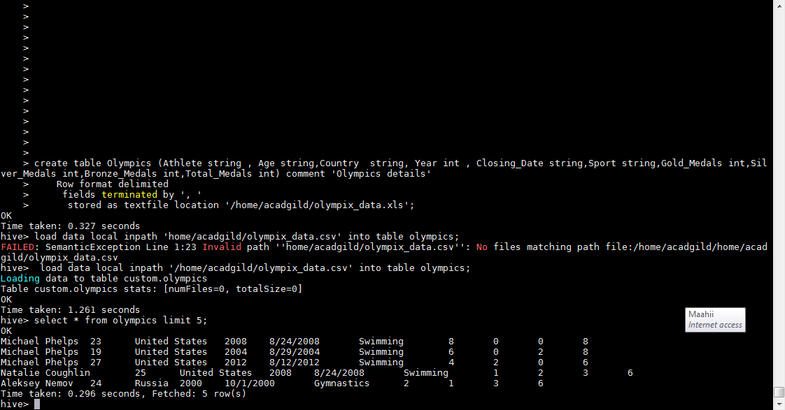

Query :

Select Country, count(Gold Medals), count(Silver_Medals), count(Bronze_Medals),count(Total_ Medals) from Olympics where Sport=’ Swimming’ group by country;

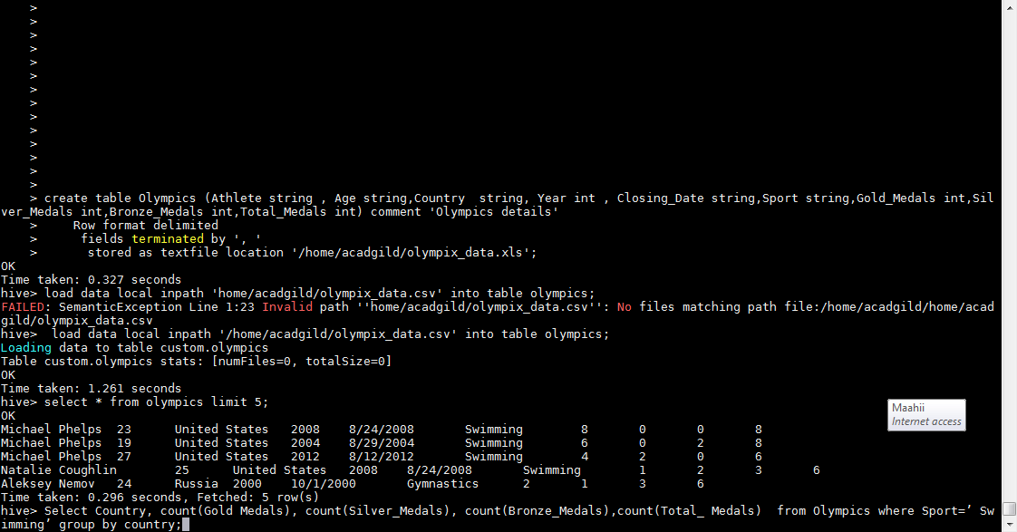

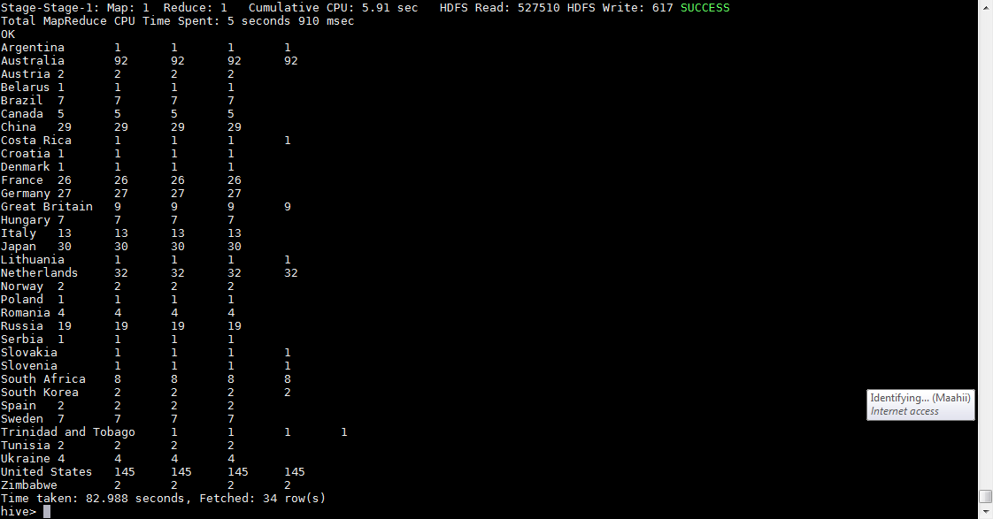

**Problem Statement**

**Write a Hive program to find the number of medals that India won year wise**

select country,year,count(gold_medals),count(silver_medals),count(bronze_medals),count(total_medals) from olympics where upper(country)='INDIA' group by country,year

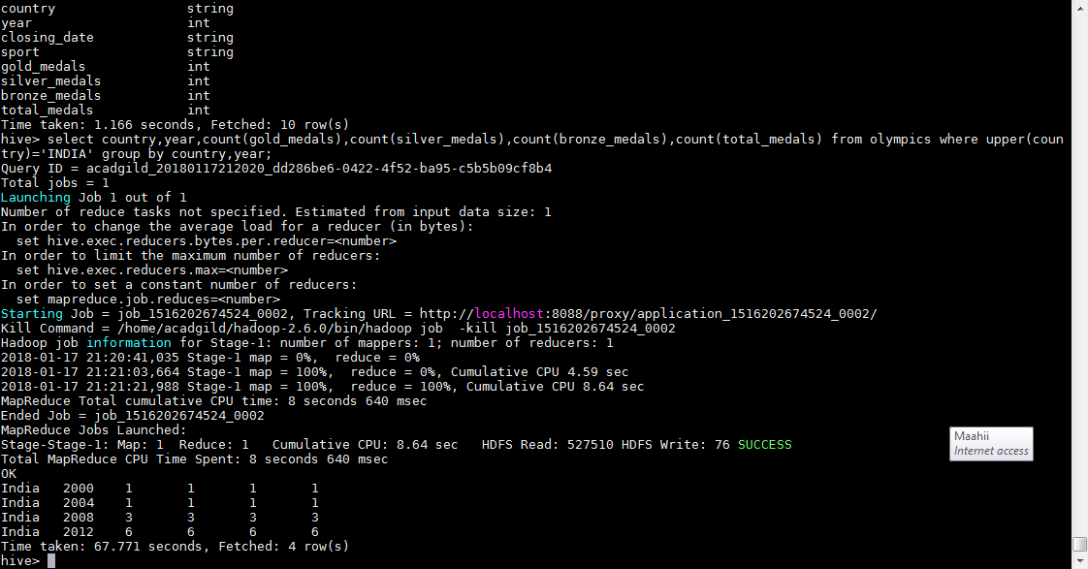

**Problem Statement**

**Write a Hive Program to find the total number of medals each country won.**

select country,count(total_medals) from olympics group by country,year

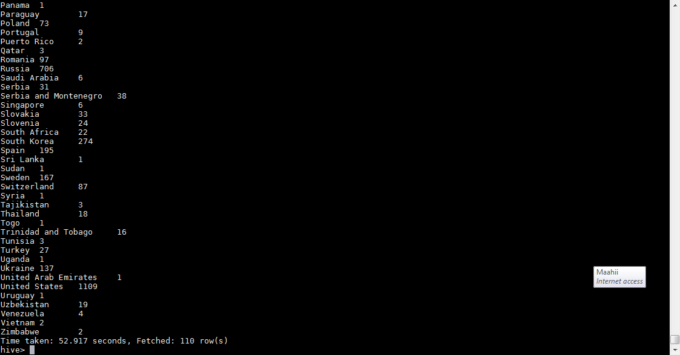

**Problem Statement**

**Write a Hive program to find the number of gold medals each country won.**

select country,count(gold_medals) from olympics group by country;

